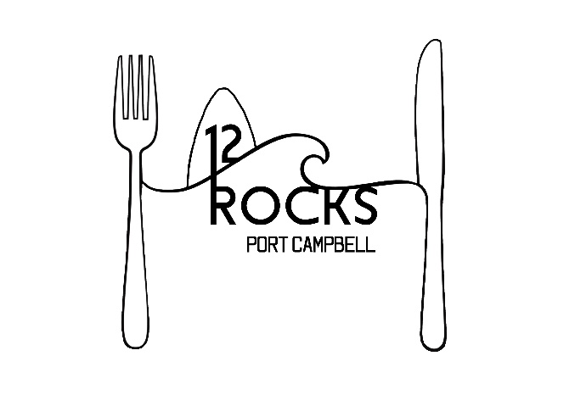

Dinner Menu

Bowl of chips $8

Garlic bread $8 /add cheese $10

Vegetarian spring rolls with a garlic soy dipping sauce $14

3 cheese margarita – tasty, mozzarella & parmesan cheese with Italian herbs (V) $18

Rocks beef burger with lettuce, cheese, tomato, egg, bacon, onion & tomato sauce on a
brioche bun served with crunchy fries (*) -Locally farmed beef- $23

Beer battered fish & chips – with crunchy fries, tartare & a side salad (*) $24

Salt & pepper calamari tossed in garlic, chilli, Chinese white wine & spring onion with
side salad $22

Chicken Parmigiana topped with napoli, leg ham, mozzarella & tasty cheese, served
with chips and salad $24

280g Waygu steak cooked to your liking with golden chat potatoes, seasonal vegetables
with your choice of a plain gravy, creamy peppercorn gravy or garlic chive butter $38

Kids meals calamari & chips, fish & chips, chicken nuggets & chips or mini Hawaiian pizza $10

Extras $2 each Hollandaise, aioli, sweet chilli, gravy’s, gluten free bread

